Name: Ali Hassaan Mughal Reg No: 173627

CREATE DATABASE

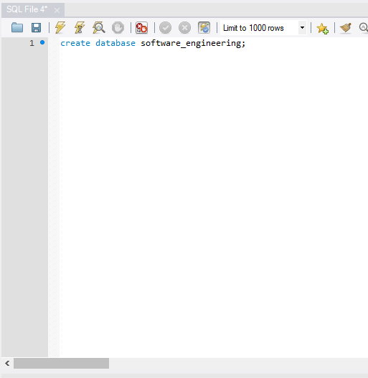

OUTPUT CREATE DATABASE

CREATE TABLE

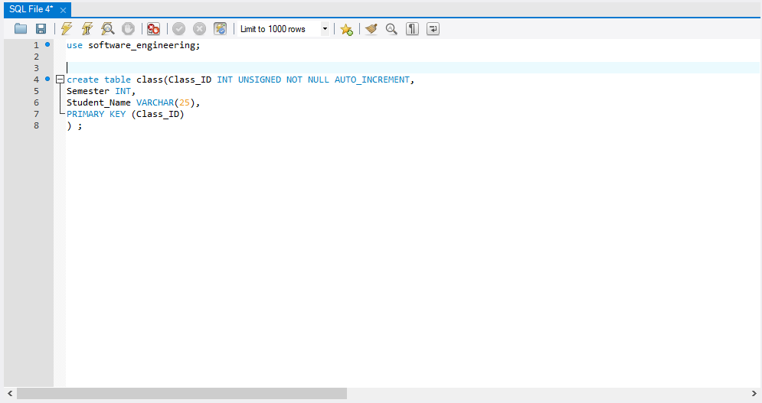

OUTPUT CREATE TABLE

ADD DATA INTO TABLE  
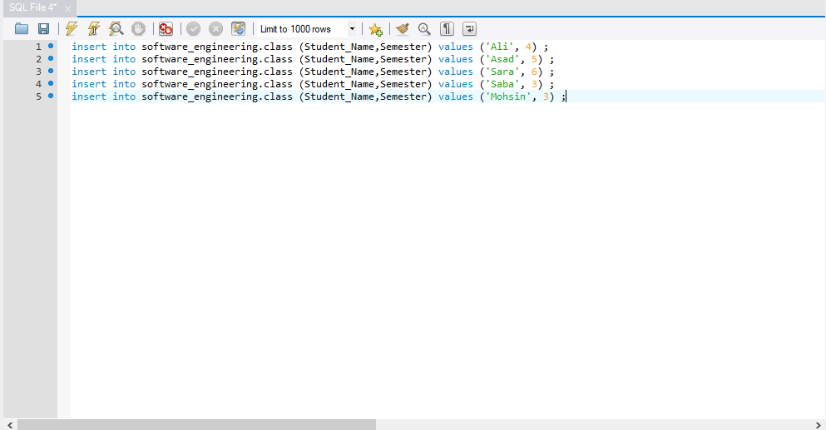

OUTPUT ADD DATA INTO TABLE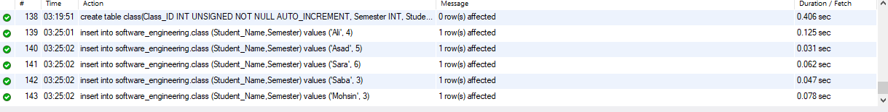

FINAL DISPLAY OF ENTERED DATA

